Acceptance Test-Driven Development (ATDD)

What is Acceptance Test-Driven Development (ATDD)
# Source: AI Source: Provided by: [Data Path: Persons Table -> ID Column: 1, Name_En Column: Motasem Essam] -> From: [Chatgpt (GPT‑5 Mini)] on [8/24/2025]
ATDD is a collaborative development approach where the team (developers, testers, product owners, and business stakeholders) define acceptance tests before development begins.
These acceptance tests describe how the system should behave from the user’s point of view. The goal is to make sure the team builds the right system that meets business needs.

🔑 Key Characteristics of ATDD
# Source: AI Source: Provided by: [Data Path: Persons Table -> ID Column: 1, Name_En Column: Motasem Essam] -> From: [Chatgpt (GPT‑5 Mini)] on [8/24/2025]
- Acceptance Criteria First
  - Tests are written before coding, based on business rules and requirements.
- Collaboration
  - All stakeholders (business + dev + test) contribute to defining tests, so there’s a shared understanding of what “done” means.
- High-Level, User-Focused
  - Tests focus on what the system should do (functionality) rather than how it is implemented.
- Executable Specifications
  - Like in BDD, acceptance tests can be automated and serve as living documentation.

📖 Example of ATDD
# Source: AI Source: Provided by: [Data Path: Persons Table -> ID Column: 1, Name_En Column: Motasem Essam] -> From: [Chatgpt (GPT‑5 Mini)] on [8/24/2025]
Feature: User login
Scenario: Login with valid credentials
Given the user is on the login page
When they enter a valid username and password
Then they should be redirected to the dashboard

- This acceptance test is defined before development.
- Developers then implement code to make this scenario pass.
- Testers validate automatically.

✅ Benefits of ATDD
# Source: AI Source: Provided by: [Data Path: Persons Table -> ID Column: 1, Name_En Column: Motasem Essam] -> From: [Chatgpt (GPT‑5 Mini)] on [8/24/2025]
- Ensures alignment with business goals (build the right thing).
- Improves communication between business, dev, and QA.
- Reduces misunderstandings and rework.
- Provides clear definition of “done” for each feature.
- Acceptance tests act as living documentation.

⚠️ Challenges
# Source: AI Source: Provided by: [Data Path: Persons Table -> ID Column: 1, Name_En Column: Motasem Essam] -> From: [Chatgpt (GPT‑5 Mini)] on [8/24/2025]
- Requires close collaboration and time investment.
- If acceptance tests are vague or incomplete, misunderstandings can still occur.
- Needs good tooling (e.g., FitNesse, Cucumber, SpecFlow).

🔄 ATDD vs BDD vs TDD (Quick Comparison)
# Source: AI Source: Provided by: [Data Path: Persons Table -> ID Column: 1, Name_En Column: Motasem Essam] -> From: [Chatgpt (GPT‑5 Mini)] on [8/24/2025]
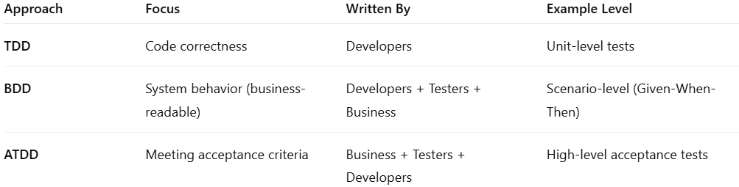
Approach | Focus | Written By | Example Level
TDD | Code correctness | Developers | Unit-level tests
BDD | System behavior (business-readable) | Developers + Testers + Business | Scenario-level (Given-When-Then)
ATDD | Meeting acceptance criteria | Business + Testers + Developers | High-level acceptance tests

⚖️ Summary:
# Source: AI Source: Provided by: [Data Path: Persons Table -> ID Column: 1, Name_En Column: Motasem Essam] -> From: [Chatgpt (GPT‑5 Mini)] on [8/24/2025]
ATDD = define acceptance tests up front with collaboration (business + dev + QA), then build code to make those tests pass.
It ensures the product meets business needs and user expectations before writing a single line of code.

